

Artificial Intelligence
( Course Code: CSC262 )

Name : Muhammad Abdullah
Roll No # FA24-BSE-042
Instructor Name : Sir Waqas

Lab # 1

Lab Task – 1

# LAB Task 1

numbers = []
while True:
x = input("Enter Number (or press Enter to finish): ")
if x == "":
break
numbers.append(x)

num_str = "".join( numbers)
reversed_num = num_str[::-1]
if reversed_num:
print(int(reversed_num))

Output:
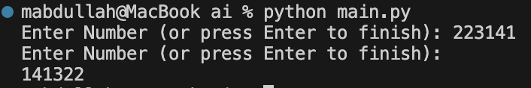

Lab Task – 2
# LAB Task 2

integers = [1,2,3,4,5,6,7,8,9,10]
even = 0
odd = 0

for num in integers:
if(num % 2 == 0):
even += num
else:
odd += num

print("Sum of Even Numbers: ", even)
print("Sum of Odd Numbers: ", odd)

Output:
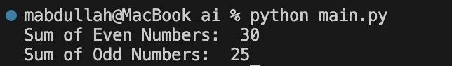

Lab Task – 3
# LAB Task 3

term = int(input("Input the number of terms: "))
def fib(n):
if n <= 1:
return n
return fib(n-1) + fib(n-2)

for i in range(term):
print(fib(i), end=" ")

Output:

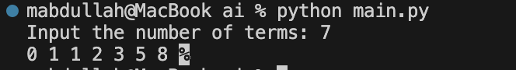

Lab Task – 4
# LAB Task 4

marks = int(input("Enter marks (1-100): "))
try:
if marks < 1 or marks > 100:
print("Invalid marks. Please enter a value between 1 and 100.")
elif marks < 50:
print("Grade F")
elif 50 <= marks <= 60:
print("Grade E")
elif 61 <= marks <= 70:
print("Grade D")
elif 71 <= marks <= 80:
print("Grade C")
elif 81 <= marks <= 90:
print("Grade B")
elif 91 <= marks <= 100:
print("Grade A")
except ValueError:
print("Invalid input. Please enter a numeric value.")

Output:

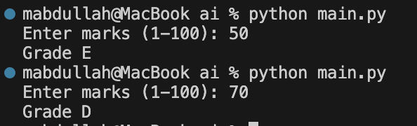

Lab Task – 5
# LAB Task 5

number = int(input("Number for factorial: "))
def factorial(n):
if(n<=1):
return 1

return n * factorial(n-1)

print(factorial(number))

Output:


